Course One

Foundations of Data Science


Instructions
Use this PACE strategy document to record your decisions and reflections as you work through this end-of-course project. As a reminder, this document is a resource that you can reference in the future and a guide to help consider responses and reflections posed at various points throughout projects.

Course Project Recap
Regardless of which track you have chosen to complete, your goals for this project are:
- Understand and assess the proposed scenario
- Demonstrate foundational knowledge of the data science workflow - PACE
- Articulate a data project proposal in the planning stage for cross-functional team members

Relevant Interview Questions
Completing this end-of-course project will empower you to respond to the following interview topics:
- As a new member of a data analytics team, what steps could you take to get 'up to speed' with a current project? What steps would you take? Who would you like to meet with?
- How would you plan an analytics project?
- What steps would you take to translate a business question to an analytical solution?
- Why is actively managing data an important part of a data analytics team's responsibilities?
- What are some considerations you might need to be mindful of when reporting results?

Reference Guide
This project has three tasks; the following visual identifies how the stages of pace are incorporated across those tasks.
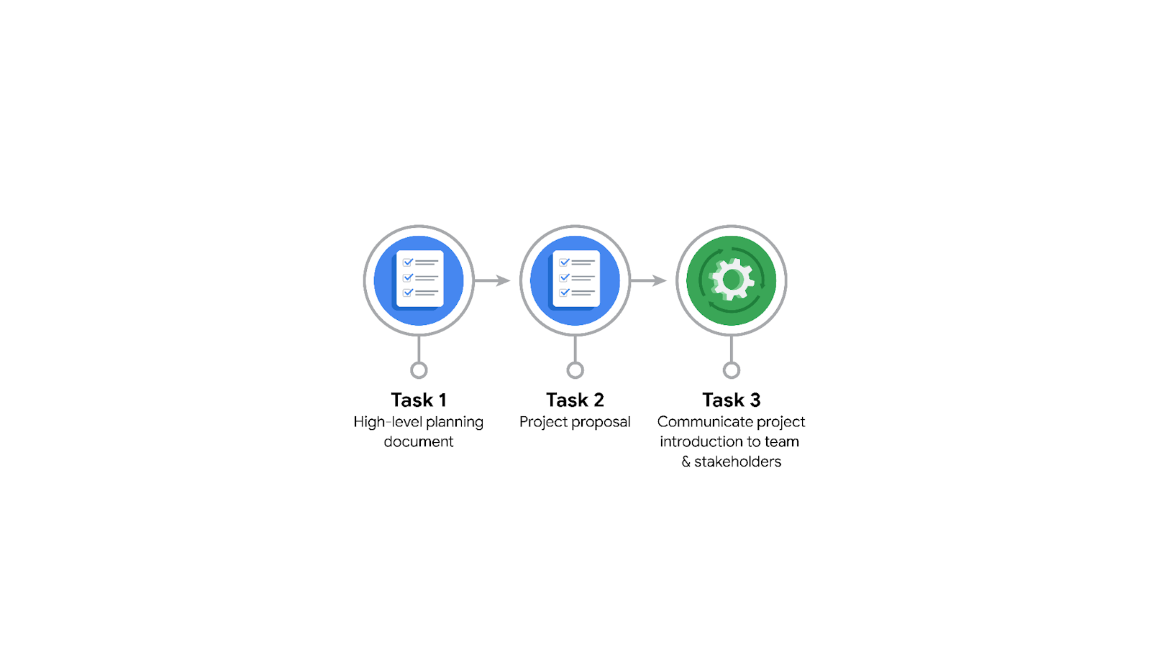

Data Project Questions & Considerations
PACE: Planning Stage
- Who is your audience for this project?
New york city TLC team.

- What are you trying to solve or accomplish? And, what do you anticipate the impact of this work will be on the larger needs of the client?
We’re trying to build a reliable prediction model for taxi fare. The estimated ride duration would help the client identify which ride took more than expected.

- What questions need to be asked or answered?
- How is the quality and consistency of the dataset?
- Is there any important variable to consider?
- Is there any input bias in the data? What steps can be taken to reduce bias?
- Are there any trends within the dataset that can provide insight?
- Why does NYC TLC want to have an estimated fare price before the ride?

- What resources are required to complete this project?
We will need the project dataset, jupyter notebook, python packages, and input from stakeholders.

- What are the deliverables that will need to be created over the course of this project?
A data set cleaned for exploratory data analysis, data visualization and trends insights from eda, reliable machine learning model for estimating taxi fare.

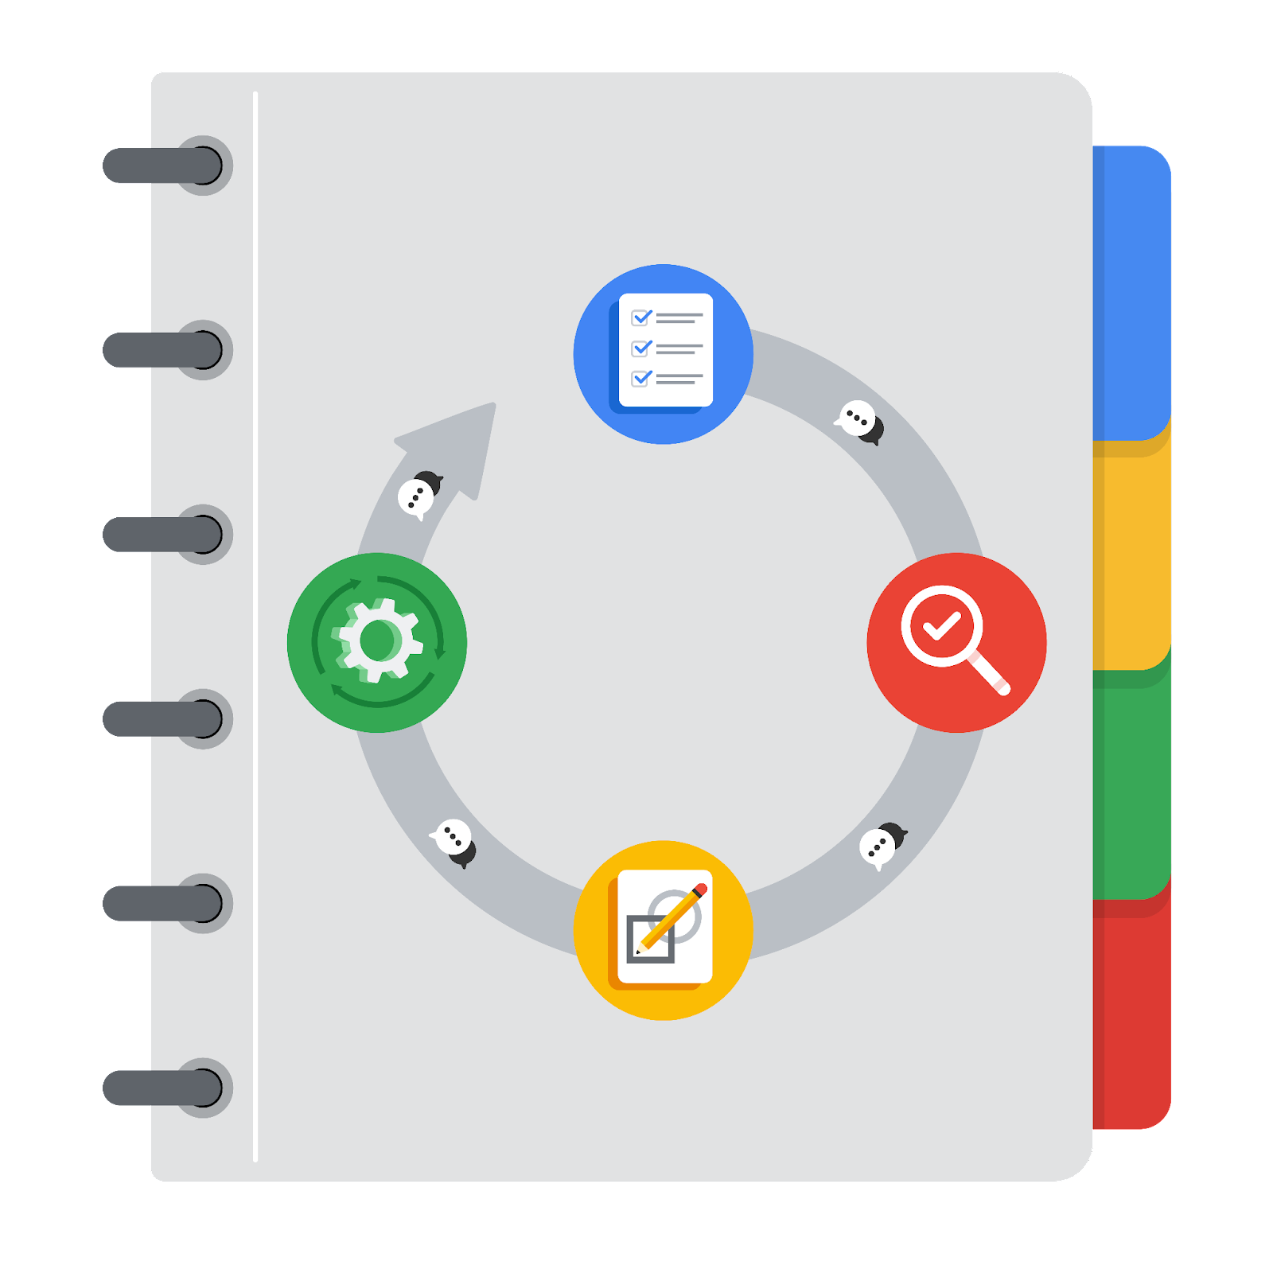
THE PACE WORKFLOW

[Alt-text: The PACE Workflow with the four stages in a circle: plan, analyze, construct, and execute.]

You have been asked to demonstrate for the company's data team how you would use the PACE workflow to organize and classify tasks for the upcoming project. Select a PACE stage from the dropdown buttons. A few tasks involve more than one stage of the PACE workflow. Additionally, not every workplace scenario will require every task. Refer back to the Course 1 end-of-course portfolio project overview: Automatidata if you need more information about the tasks within the project.

Project tasks
Following are a group of tasks your company’s data team has determined need to be completed within this project. The data analysis manager has asked you to organize these tasks in preparation for the project proposal document. First, identify which stage of the PACE workflow each task would best fit under using the drop down menu. Next, give an explanation of why you selected the stage for each task. Review the following readings to help guide your selections and explanation: The PACE stages and Communicate objectives with a project proposal. You will later reorder these tasks within a project proposal.

- Evaluating the model: Execute
Why did you select this stage for this task?
While evaluating the model, we’re trying to analyze the performance or accuracy of the estimated ride duration with validation data.

- Conduct a hypothesis test: Analyze and Construct
Why did you select these stages for this task?
During the analyzing stage, it is determined that a statistical test will be needed to check the hypothesis made. During the construction phase, the test is carried out which allows in validating hypotheses.

- Understanding the data: Analyze
Why did you select this stage for this task?
We understand the data by tools like exploratory data analysis and identify relationships between features, and the distribution of variables.

- Data exploration and cleaning: Plan and Analyze
Why did you select these stages for this task?
Planning takes place first about the methods that need to be performed for data exploration and cleaning. Analyzing takes place when understanding the data using cleaning and exploration.

- Establish structure for project workflow (PACE): Plan
Why did you select this stage for this task?
In the planning stage, the team identifies the problem, solutions, tools requirements, and project workflow.

- Communicate final insights with stakeholders: Execute
At the end of the analysis and modeling, once we’re confident about the insights, we share the insights with stakeholders with the help of visualization, documentation, and video.

- Compute descriptive statistics: Analyze
Why did you select this stage for this task?
We investigate the data using the descriptive statistics during analysis to understand the data.

- Visualization building: Construct and Analyze
Why did you select these stages for this task?
We build visualizations to share the insights with the stakeholders and complete the project.

- Write a project proposal: Plan
Why did you select this stage for this task?
Project proposal is the very first step in any project. It is either used to get an approval from the client and to give an overview of the project (intent and solution) to the higher-level.

- Build a regression model: Analyze and Construct
Why did you select this stage for this task?
We will build regression models in this project to estimate the ride duration. This helps in understanding the data (analyze) through the relationship between a feature and ride duration. Models are the primary aim of this project, and it would be done in the construct stage.

- Inspect the data set for missing data: Analyze
Why did you select this stage for this task?
We analyze the data identify missing values and clean the dataset

- Build machine learning model: Construct
Why did you select this stage for this task?
The machine learning model is build at the construct stage for predicting or estimating a dependent feature.

